A Multi-Criteria Based Approach for Large-Scale Deployment of CO₂ Capture, Utilization and Storage
Thuy Thi Hong Nguyen*, Satoshi Taniguchi, Takehiro Yamaki, Nobuo Hara, Sho Kataoka
National Institute of Advanced Industrial Science and Technology
1-1-1 Higashi, Tsukuba, Ibaraki 305-8565, Japan
Corresponding author email: nguyen.thuy@aist.go.jp
Abstract
In this study, CCU was coupled with CCS to totally abate the target CO₂ emission sources in an economically viable manner. Herein, CO₂ was captured from a target source, and separated into two different streams, one of which was prepared for storage. The remaining CO₂ stream, together with H₂, was utilized for methane production. Rigorous process design was performed to provide necessary data for constructing a multi-criteria based evaluation model, based on which the total system is optimized for maximizing both total economic benefit and CO₂ abatement. The results show that coupling CCU with CCS can help reduce the incurred cost and achieve high CO₂ reduction when a low carbon tax rate (i.e., $130/ton) is applied and when a low-cost H₂ source (i.e., below $1.3/kg) is available. CCU is not necessary to be coupled with CCS if a higher carbon tax rate is applied or when a large supply of low cost green H₂ is available.
Keywords: Carbon capture and utilization/storage, rigorous process design, multi-criteria based evaluation model, economic benefit, CO₂ abatement
1. Introduction
Greenhouse gases (GHG), mainly due to CO₂ emissions, have become a worldwide concern. CCS and CCU are key technologies for mitigation of CO₂ emissions. In Japan, utilizing CO₂ for methane synthesis and storing CO₂ at available injection well sites have been considered as important strategies to fulfil the domestic energy demand and to achieve the target GHG emissions reduction. Large-scale implementation of either CCS or CCU is limited due to some technical challenges (Dziejarski et al., 2023) and economic drawbacks (Chen at al., 2022). CCS incurs additional cost for CO₂ capture, liquefaction, transport and injection (Storrs et al., 2023). CCU can lead to much lower CO₂ emissions than CCS while creating new added value products. Thus, coupling CCU and CCS is expected to be a wise strategy for abating large-scale CO₂ emissions economically. However, most of CCU processes need large supplies of heating utilities and raw materials (Hao et al., 2022). In addition, allocating suitable amounts of CO₂ for storage and utilization is the key to sustaining economic and environmental viability of an integrated CCUS system. Therefore, optimizing the entire system is strongly needed.
In this study, an integrated CCUS system producing e-fuel as the main product is designed and optimized. Herein, CO₂ is captured from a target source, and separated into two different streams, one of which is liquefied, transported to an injection site, and injected while the other CO₂ stream, together with H₂, is utilized for methane production. A multi-criteria evaluation model is built. It is used to evaluate and optimize the entire system by maximizing total economic benefit and CO₂ emission reduction. The impacts of external factors such as carbon tax rate and H₂ cost and sources (i.e., grey and green sources) on total process performances are also investigated.
2. Method of study
Figure 1 shows the boundary of the coupling CCUS system considered in this study. The flue gas containing CO₂ is led to the capture process, in which CO₂ is captured by monoethanolamine solvent and purified. A fraction amount of the CO₂ product stream is led to the liquefaction process, producing liquid CO₂ which is then transported to the injection site and stored underground. The rest amount of CO₂ is mixed with hydrogen and it is used as input for the methane production process, in which methane is synthesized following reaction (1) and purified. The product methane can be sold and used as a replacement to the conventional natural gas fuel.
CO₂ + 4 H₂ ⇌ CH₄ + 2 H₂O ΔH_{298K} = -165 kJ/mol (1)
In this study, the following assumptions are made for process design and optimization:
- CO₂ is captured from a target emission source at a rate of 208.4 t/h
- Amine-based capture process, CO₂ liquefaction and methane production processes are located nearby the CO₂ emission source.
- The liquid CO₂ is transported by ship for 1,000 km.
- Different sources of H₂, both grey and green sources, are available and their amounts are unlimited.
- The produced methane can be used for many purposes; thus, its demand is unlimited.
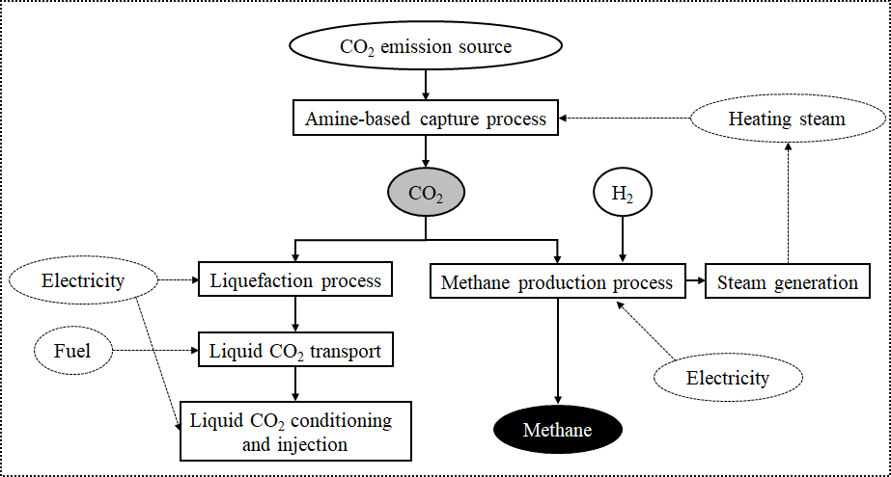
The methane production and CO₂ liquefaction processes are designed using process simulator Pro/II (developed by AVEVA, 2022). The structure and operating conditions (i.e., temperature and pressure) of each process are also optimized to reduce its energy consumption and material loss. However, separately optimizing each process is not necessary a guarantee of an optimal coupling CCUS system which would yield high economic benefit and low CO₂ emissions. Therefore, to optimize the target of the integrated CCUS system, a multi-criteria based evaluation model is constructed. It consists of two evaluation indicators, the net present value (NPV) and the potential CO₂ reduction (PCR), which are used for maximizing economic benefit and CO₂ abatement amount. The model is operated using some fundamental data such as mass and energy balance data obtained from the above process design and simulations, life cycle assessment database, and market price data.
Figure 1. Boundary of process design and evaluation
Here, NPV ($) accounts for all kinds of investment and operating costs (i.e., process plant construction, injection well, CO₂ transport, energy and raw material consumption costs, etc.) and benefits gained from selling the product produced by the system (Biegler et al.,1997). Basic parameters used for evaluating NPV are shown in Table 1. PCR (t CO₂/year) is the sum of all direct and indirect CO₂ emissions due to energy and raw material consumptions minus the amount of CO₂ avoided due to substitution of conventional natural gas. The scales of CO₂ utilization and storage, which depend on the fractions of CO₂ utilized and stored, respectively, directly impact the amounts of salable product (i.e., methane), the size of process equipment, and the amounts of raw material and energy consumed. As a result, they directly impact the evaluation indicators NPV and PCR. Therefore, the optimization problem is defined as following:
max NPV = f (w₁, w₂) (2)
max PCR = g (w₁, w₂) (3)
subject to: w₁ + w₂ = 1 (4)
Here, w₁ and w₂ are fractions of CO₂ utilized for methane production and stored, respectively.
Table 1. Basic parameters used for evaluating NPV.
Operating hours per year | 8400 hours
Useful plant life | 15 years
Depreciation life (straight line method) | 12 years (straight line method)
Contingency and fee costs | 20% bare module cost
Auxiliary facilities costs | 20% bare module cost
Working capital | 19.4% fixed capital investment cost
Labor | 10% operating cost
Other cost (maintenance, supplies, etc.) | 11% process capital cost
Tax rate | 35%
After tax rate of return | 10%
The optimization of each objective is performed using an optimization solver, namely What’s Best (an add-in to Excel) (Lindo Systems Inc., 2023). To support different stakeholders to make decision based on different targets of CO₂ abatement, different target PCR values, calculated based on ε (varying in the range of 0 and 1) and optimal PCR result, are assigned as constraints (equation (5)) for optimizing the NPV.
Target PCR = ε*PCR_{max} (5)
To illustrate evaluation results, varying in wide ranges, the following equations are used to normalize the NPV and PCR results:
${NPV}_{Norm}=exp\left({NPV}/{{NPV}_{max}}\right)$ (6)
${PCR}_{Norm}=exp\left({PCR}/{{PCR}_{max}}\right)$ (7)
Thus, when NPV_{Norm} is higher than 1, economic benefit is gained, and vice versa. When PCR_{Norm} is higher than 1, CO₂ emission can be reduced, and vice versa.
3. Evaluation result
To examine the impact of the external factors on the evaluation objective NPV and PCR, different scenarios of carbon tax rates and H₂ sources and prices (S1 – S6) were considered. As Table 2 clearly shows, the optimal results of NPV and PCR markedly change when these external factors change. Figure 2 shows the changing tendencies of these objectives as functions of fraction amount of CO₂ utilized for methane production.
Table 2. Different scenarios considered in this study.
Scenario ID | S1 | S2 | S3 | S4 | S5 | S6
Input conditions
H₂ type | Grey | Grey | Green | Green | Green | Green
H₂ price ^{a)}  ($/kg H₂) | 1.26 | 1.26 | 2.0 | 2.0 | 1.3 | 1.3
H₂’s CO₂ factor^{a)}  (kg CO₂/kg H₂) | 12.4 | 12.4 | 1.99 | 1.99 | 1.99 | 1.99
CH₄ price^{b)}  ($/kg CH₄) | 0.88 | 0.88 | 0.88 | 0.88 | 0.88 | 0.88
Carbon tax rate  ($/ton CO₂) | 0 | 130 | 0 | 130 | 0 | 130
Optimization results
max NPV  (x $100MM) | 5.90 | 4.75 | 8.59 | 1.14 | 5.11 | 14.8
max PCR  (MMt CO₂/year) | 0.96 | 0.96 | 1.58 | 1.58 | 1.58 | 1.58
a) data are obtained from Parkinson et al., (2019)
b) average value in Japan as of 2022 (New Power Net, 2022)
As the results clearly show, S1 can gain some economic benefit when CO₂ in the target source is utilized for methane production. However, because grey H₂ has extremely high CO₂ emission factor, the total amount of CO₂ emitted is much higher than the amount of CO₂ utilized and avoided. As a result, PCR_{Norm} result is lower than 1 when w1 increases. Thus, with the conditions of S1, CO₂ emissions cannot be reduced. S2, using the H₂ source similar to S1, has much worse economic performance, as the carbon tax rate increases from 0 to $130/ton.
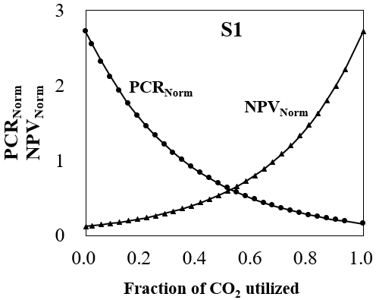
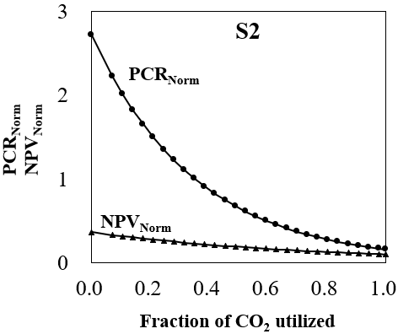
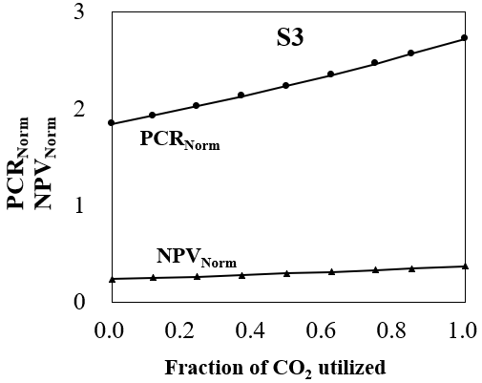
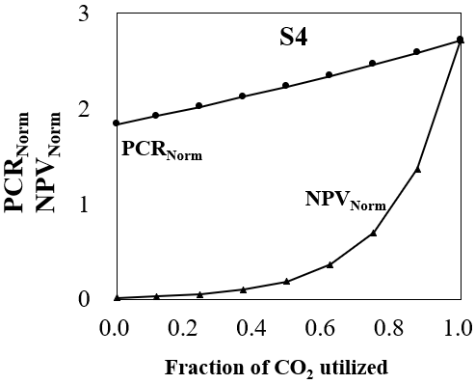
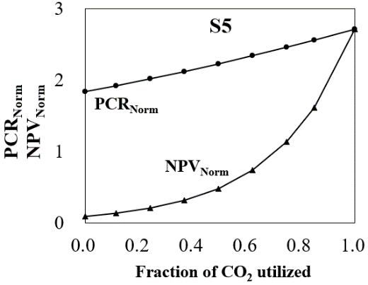
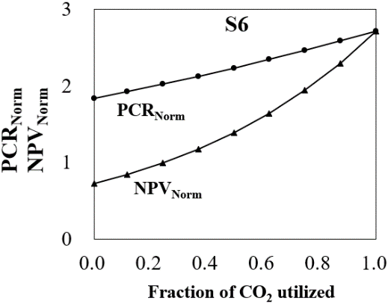
Scenarios S3-S6 use green H₂ source, thus, their PCR_{Norm} results are always higher than 1, indicating high potential of CO₂ abatement. However, their economic viability heavily depends on the H₂ market price and on the carbon tax rate. When the H₂ price increases beyond $1.5/kg, a carbon tax rate of at least $130/ton CO₂ is required to compensate for the H₂ cost expense and to make the target system economically viable (scenario 4). A H₂ price below $1.3/kg (scenarios S5 and S6) will make the target system economically feasible without need of applying carbon tax.
Figure 2. Changing tendencies of NPV_{Norm} and PCR_{Norm} towards CO₂ utilization fraction
4. Conclusion
In this study, a coupling CCUS system was designed for abating the target fixed CO₂ emission source. Here, methane is considered as the main product. Based on a constructed multi-criteria evaluation model, the system was optimized, considering different scenarios of carbon tax rate and H₂ sources. The optimization results show that when grey H₂ is used and low carbon tax rate is applied, coupling CCU and CCS can help reduce the additional cost incurred by CCS and increase CO₂ emission reduction. Nevertheless, when large supply of green H₂ is available and high carbon tax rate is considered, it is more economically and environmentally beneficial for the whole amount of CO₂ to be utilized for methane production.
References
AVEVA, PRO/II simulation v2022. https://www.aveva.com/en/products/pro-ii-simulation/.
L.T. Biegler, I.E. Grossmann, A.W. Westerberg, 1997, Systematic methods of chemical process design. Prentice Hall PTR, Upper Saddle River, N.J.
S. Chen, J. Liu, Q. Zhang, F. Teng, B.C. McLellan, 2022, A critical review on deployment planning and risk analysis of carbon capture, utilization, and storage (CCUS) toward carbon neutrality, Renewable and Sustainable Energy Reviews 167, 112537.
B. Dziejarski, R. Krzyżyńska , K. Andersson, 2023, Current status of carbon capture, utilization, and storage technologies in the global economy: A survey of technical assessment, Fuel 342 127776.
Z. Hao, M.H. Barecka, A.A. Lapkin, 2022, Accelerating net zero from the perspective of optimizing a carbon capture and utilization system. Energy & Environmental Science 15, 2139-2153.
Lindo Systems Inc, 2023, What'sBest! 18 - Excel add-in for linear, nonlinear, and integer modeling and optimization. Available at: https://www.lindo.com/index.php/products/what-sbest-and-excel-optimization.
New Power Net, 2022, Statistical data of comodity. Available at: https://pps-net.org/statistics/gas. (in Japanese)
B. Parkinson, P. Balcombe, J.F. Speirs, A.D. Hawkes, K. Hellgardta, 2019, Levelized cost of CO₂ mitigation from hydrogen production routes, Energy & Environmental Science, 12, 19-40.
K. Storrs, I. Lyhne, R. Drustrup, 2023, A comprehensive framework for feasibility of CCUS deployment: A meta-review of literature on factors impacting CCUS deployment, International Journal of Greenhouse Gas Control, 125, 103878.
J.D. Tapia, J.Y. Lee, R.E.H. Ooi, D.C.Y. Foo, R.R. Tan, 2018, A review of optimization and decision-making models for the planning of CO₂ capture, utilization and storage (CCUS) systems, Sustainable production and consumption 13, 1-15.

